Instructions:

* No talking during the exam
* Instructor cannot assist in the exam
* The exam is an open book
* If you complete the exam early, you may be dismissed

**There are 7 print screens, each worth 14.2%**

**Project**

1. Using SQLite, create a database and label it as **Q2DB.**
   1. Be sure to point to the database just created.
2. Using SQL Script, design the following table and enter the information below, be sure to use SQL script.

**Table Name:** Warehouse

|  |  |  |  |  |
| --- | --- | --- | --- | --- |
| **WarehouseID (place a primary key)** | **Location** | **Bin** | **Category** | **QTY** |
| 100 | SE | 1211 | Electronics | 1000 |
| 200 | NE | 3232 | Household Products | 2000 |
| 300 | W | 4343 | Food Items | 3000 |
| 400 | N | 4322 | Misc. | 4000 |
| 500 | S | 4342 | Clothing | 5000 |
| 600 | E | 1121 | Footwear | 6000 |

1. Create a new python application and connect to the database and display all columns with rows.

**#1 run the python application and print screen the output below here.**

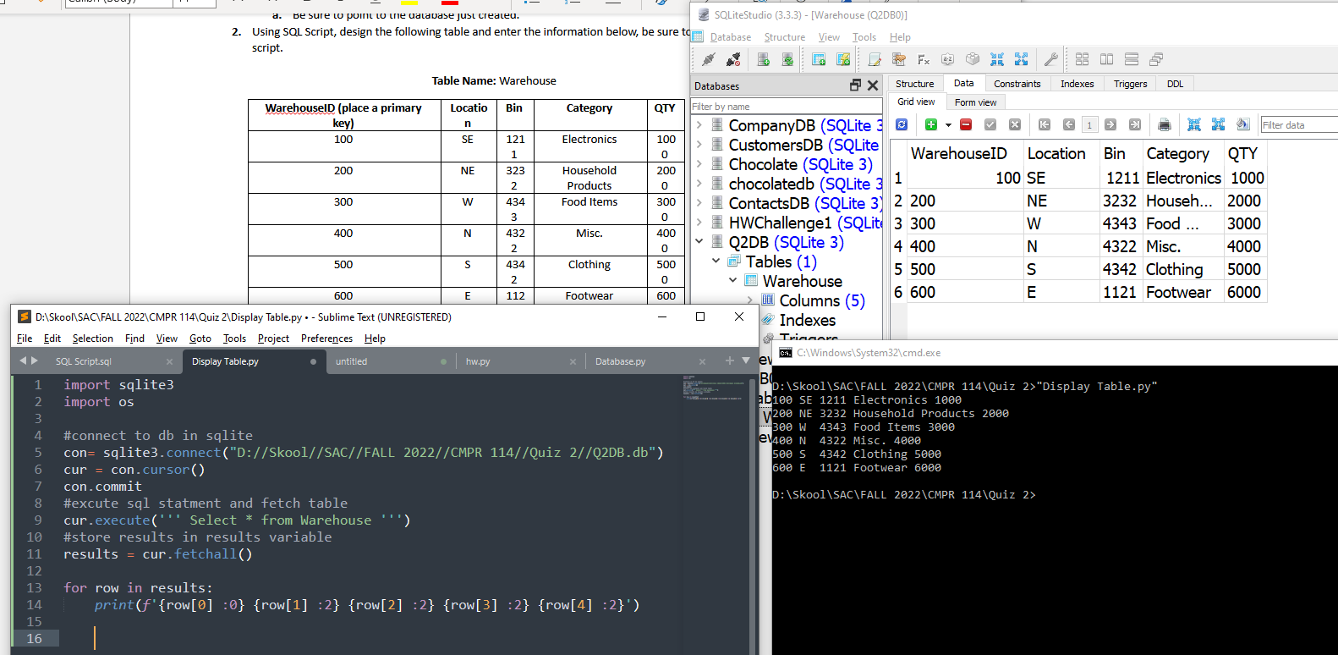

1. On the python application, display the total of the QTY.

**#2 run the python application and print screen the output below here.**

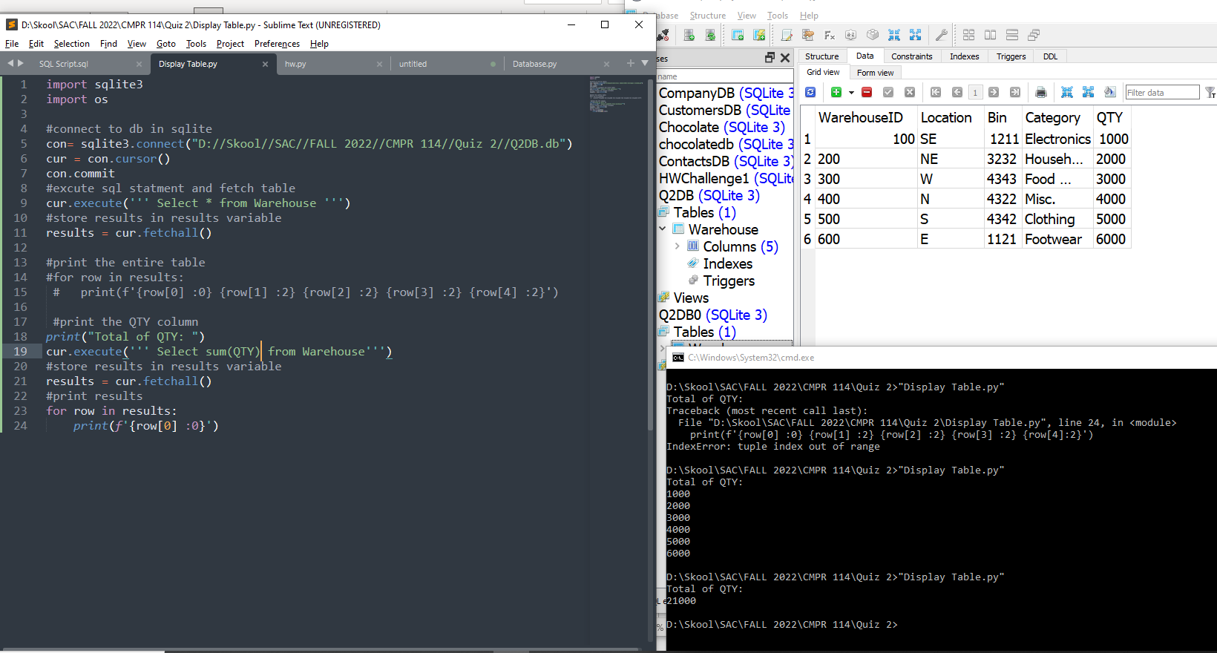

1. On the python application, display all category that ends with the letter s. Remember, to use the LIKE statement.

**#3 run the python application and print screen the output below here.**

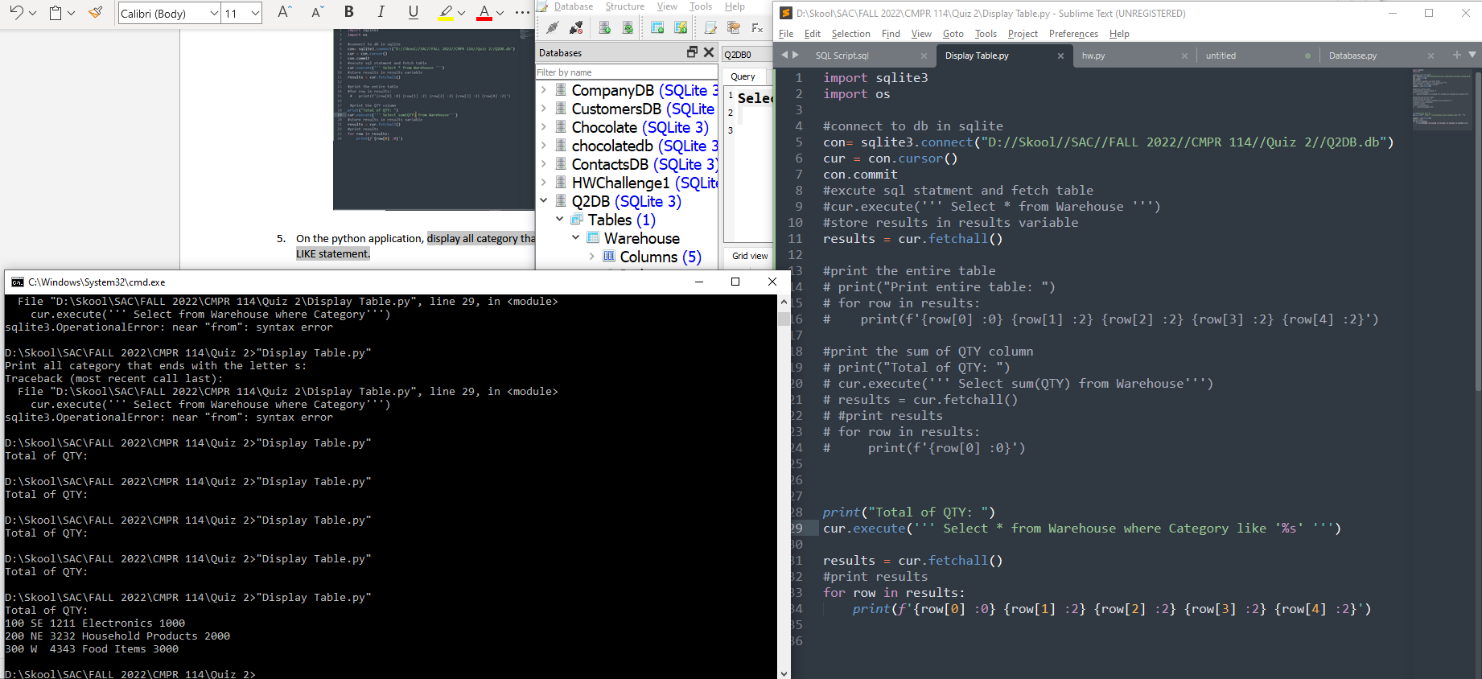

1. On the SQLite using the update statement change BIN # 1211 to 1231

**#4 run the SQL Script and print screen the output below here.**

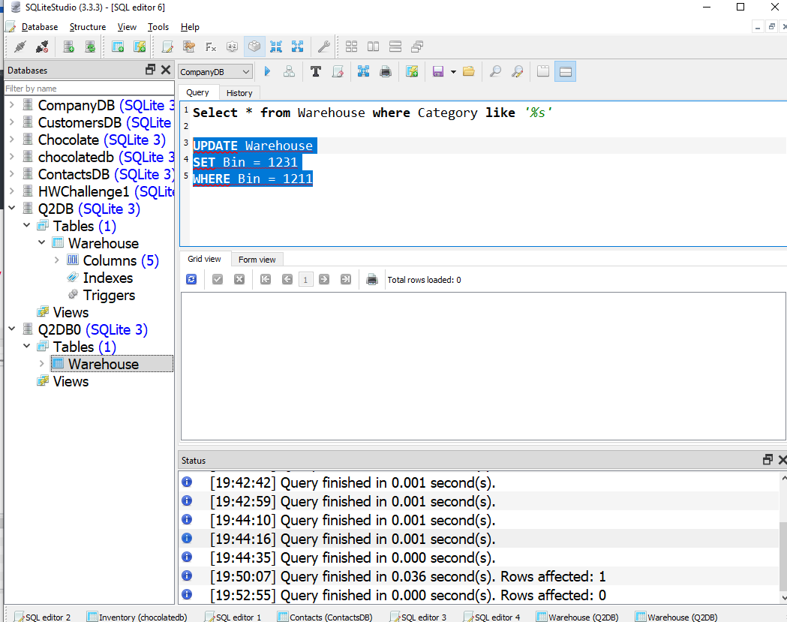

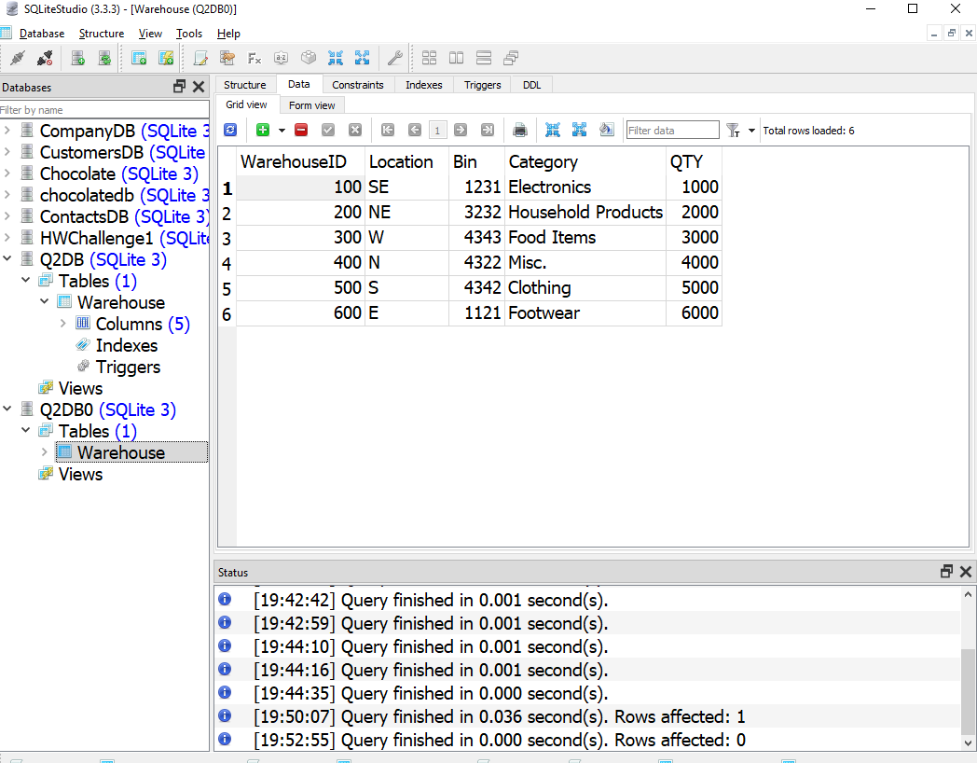

1. Using SQL Script, create a second table as shown below.

Table Name: **Region**

|  |  |  |
| --- | --- | --- |
| **RegionID (place a primary key)** | **WarehouseID (place a foreign key here that will reference the table above)** | **Region** |
| 1A | 100 | Europe |
| 2A | 200 | North America |
| 3A | 300 | Asia |
| 4A | 400 | South America |
| 5A | 500 | Africa |
| 6A | 600 | Australia |

1. Now, using python join the two tables, however, only display the location, bin, category, qty, and region columns from the two tables created earlier.

**#5 run the python application and print screen the output below here.**

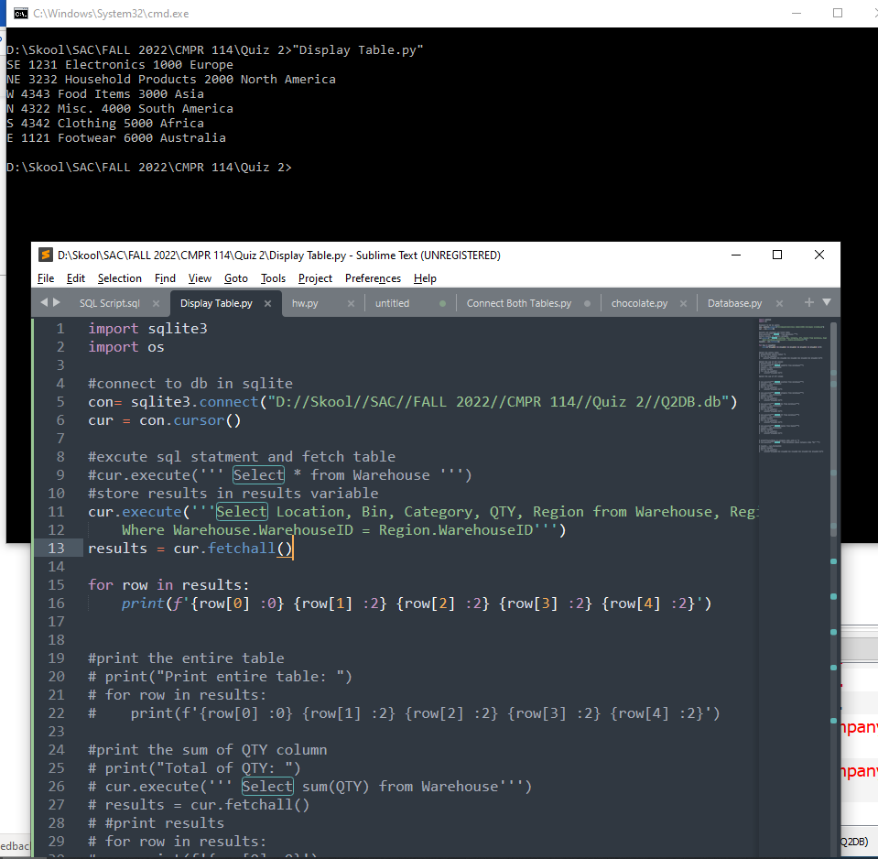

1. Using SQLite, write the SQL script to delete the Warehouse ID of 100 from the Warehouse table.

**#6 Explain why this SQL script gave an error below here:**

SQLLite won’t give an error because it doesn’t care about relationships

Now, write the SQL script so you will have the ability to delete the Warehouse ID of 100, in other words, which approach will you take to make sure that row is deleted?

**#7 print screen the SQL script below here and issue a select * from Warehouse and print screen it below also.**

**Submit this document to Modu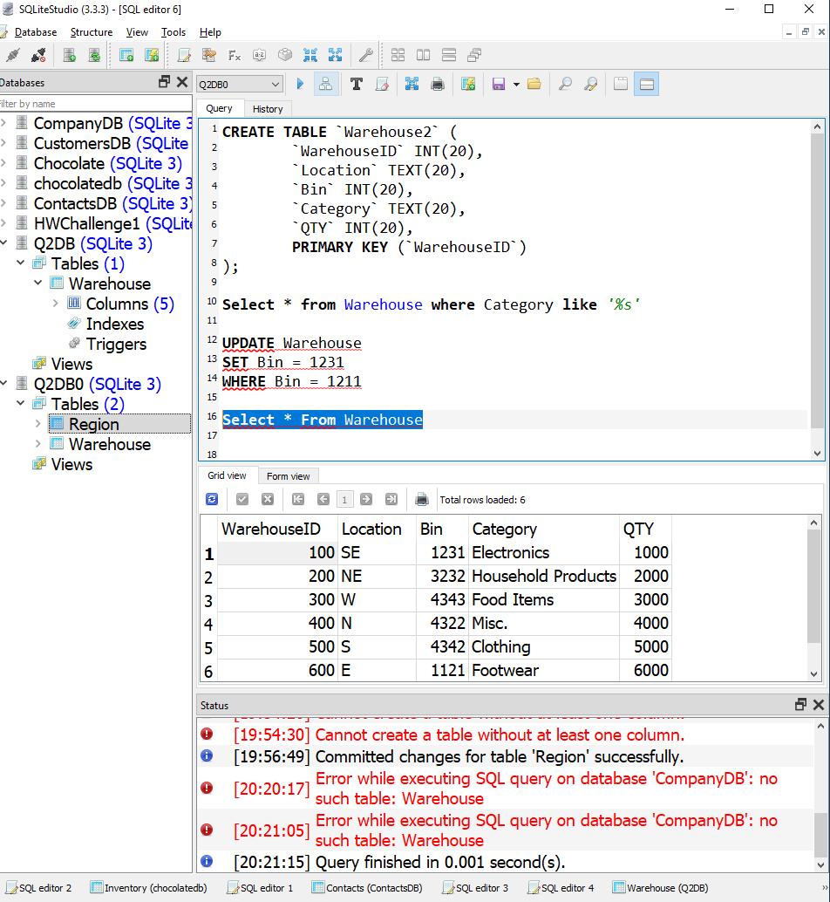le 12 quiz.**